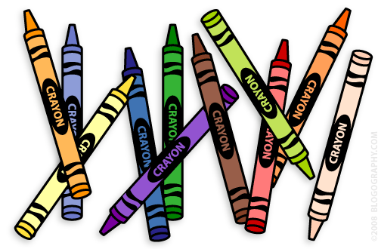**Our 1st Grade Classroom News**

**The Week of Nov. 21st – Dec. 2nd**

**Email:** [**Lweeks@bluevalleyk12.org**](mailto:Lweeks@bluevalleyk12.org)

**Website:** [**www.bluevalleyk12.org/hes/lweeks**](http://www.bluevalleyk12.org/hes/lweeks)

- This newsletter is for 2 weeks because of Thanksgiving Break. The homework is not due until December 2nd.

* We are working on long o spelled oa, ow, and oe (etc. boat, low, toe).
* You might hear your child mention something about [www.tenmarks.com](http://www.tenmarks.com). I have introduced this website to the kids last week to do during centers. They probably have their username and password memorized. Please don’t have them use this website at home if they ask to. I can get very accurate reports about their progress through this website and would like to keep this as a school activity. If you need ideas for your kids to use at home, have your child go to the website I created that has a ton of games that target our skills in math! Here is the website: <http://firstgrademathbv.weebly.com/1st-grade-games.html>

**Important Info**

**Upcoming Events**

**Math Challenge of the Week:**Last week we continued to work on fact families. Challenge your child to come up with more challenging fact families that use double digits. Here are some example problems they could use:   
20+10=?? 25+5=?? 13+11=?? 15+7=??

Have them come up with at least 4 number sentences to complete all of the fact family. They can use the example problems above. Reminder of what a fact family is check the example below:  
24+12=36 / 12+24=36 / 36-24=12 / 36-12=24

**Reading Challenge of the Week:** Last week we focused on text-to-self and text-to-text connections while we read. Text-to-self connection is when they make a connection with something in the story with something in their own lives. Text-to-text connection is when they make a connection with part of a story with another book they have read. Have your child make a text-to-text connection with a book they read this week. How does that book relate to another book they have read? Have them explain the connection in their notebook!

**Writing Challenge of the Week:** Last week we focused on what we are thankful for. Have your child make a list of at least 6 things they are thankful for in their notebooks.

**Tech of the Week**

**Website of the Week:** [Greg Tang](http://gregtangmath.com/games) has a great website full of fun math games. These games are a bit more challenging so great for enrichment for someone who loves math!   
<http://gregtangmath.com/games>   
  
**App of the Week:** [Sock Puppets](https://itunes.apple.com/us/app/sock-puppets/id394504903?mt=8) is a great one and is very useful. Students can use this app to retell a story or act out a story they wrote by using sock puppets! They can record their voices and use the sock puppets as the characters. Each sock puppet actually has their own little fun voice when you play it as well!

**Nov 23-25th**  No School

**Dec 1st** Nov.Reading Charts Due

**Dec 6th** Early Release Day

**Dec 20th** ½ day of School

**Dec 21st – Jan 3rd**  No School

**Jan 4th** Dec. Reading Charts Due

**Challenges of the Week**